REACTIVE STRENGTH INDEX -MODIFIED

<https://valdperformance.com/news/rsi-mod-made-simple>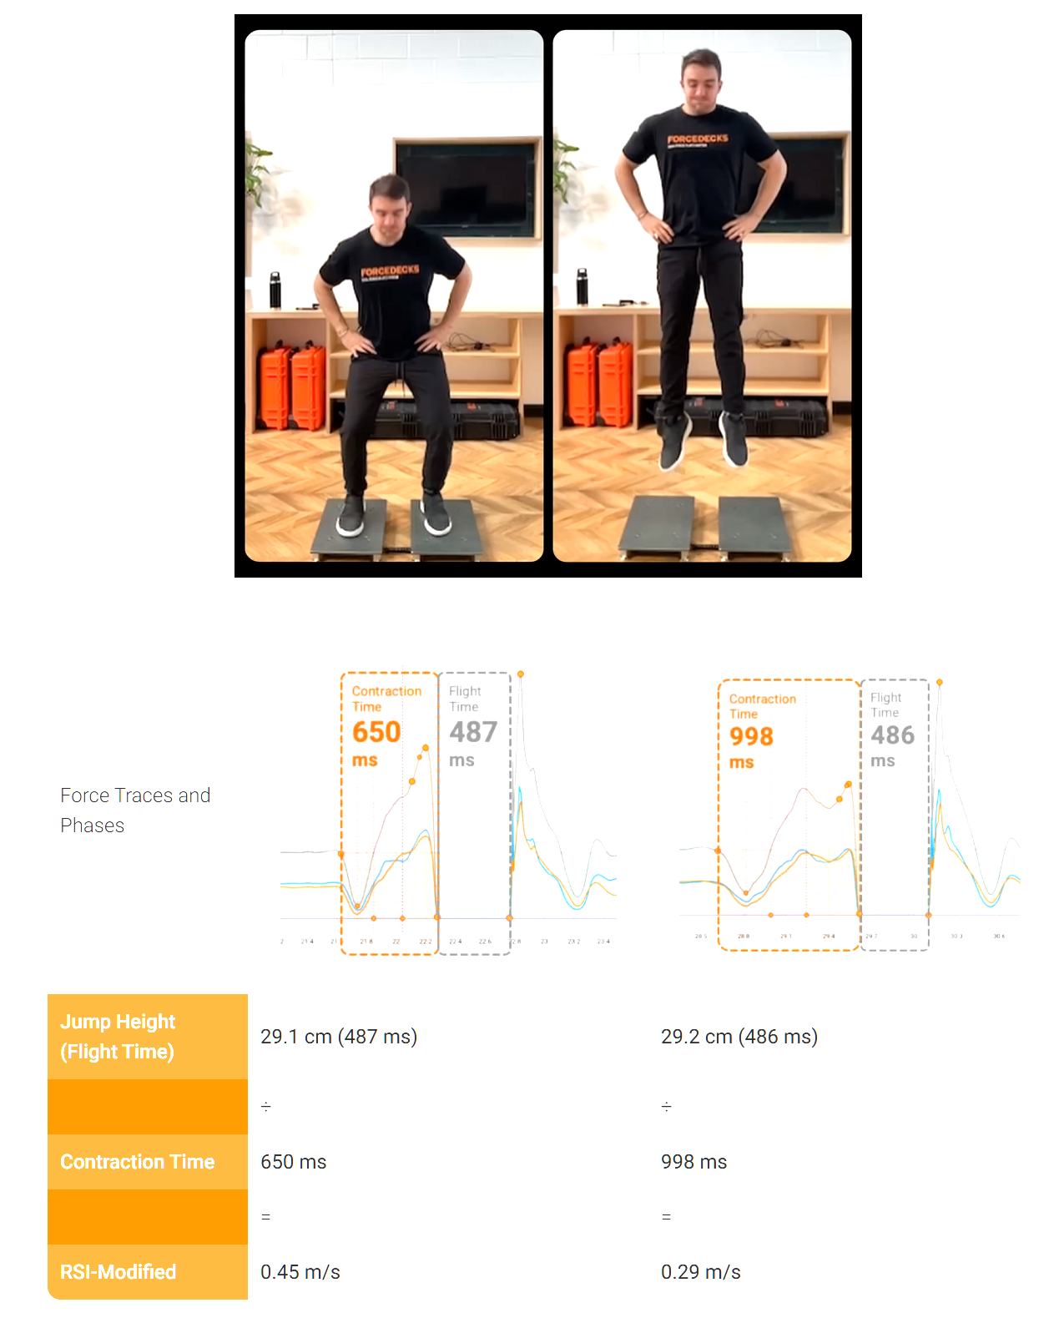

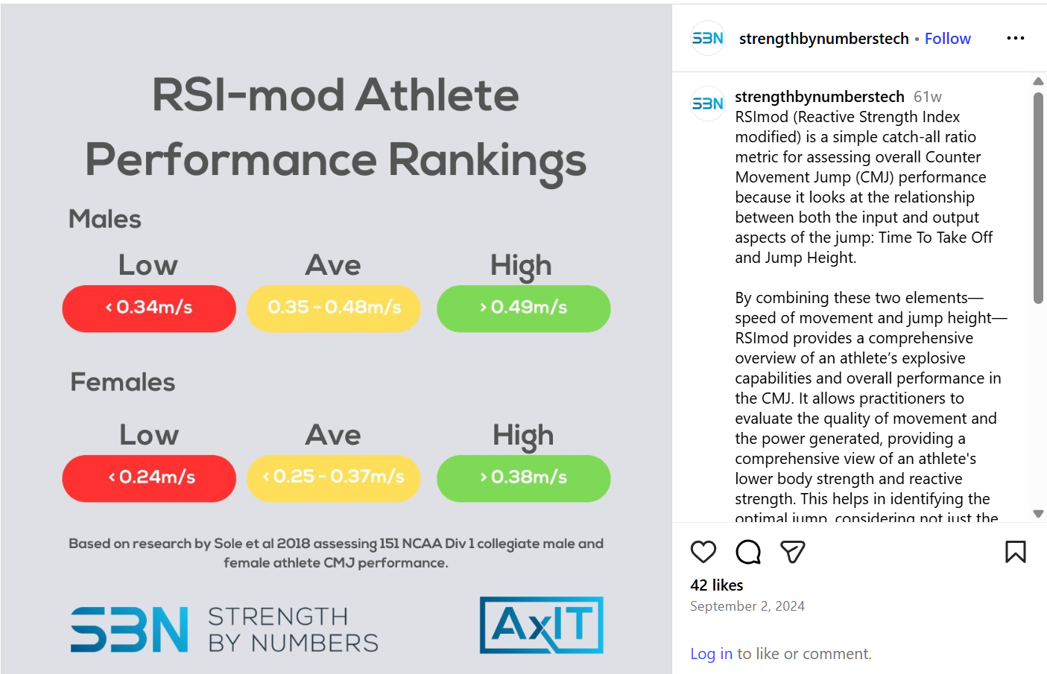

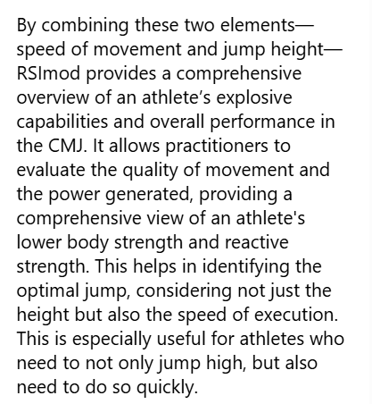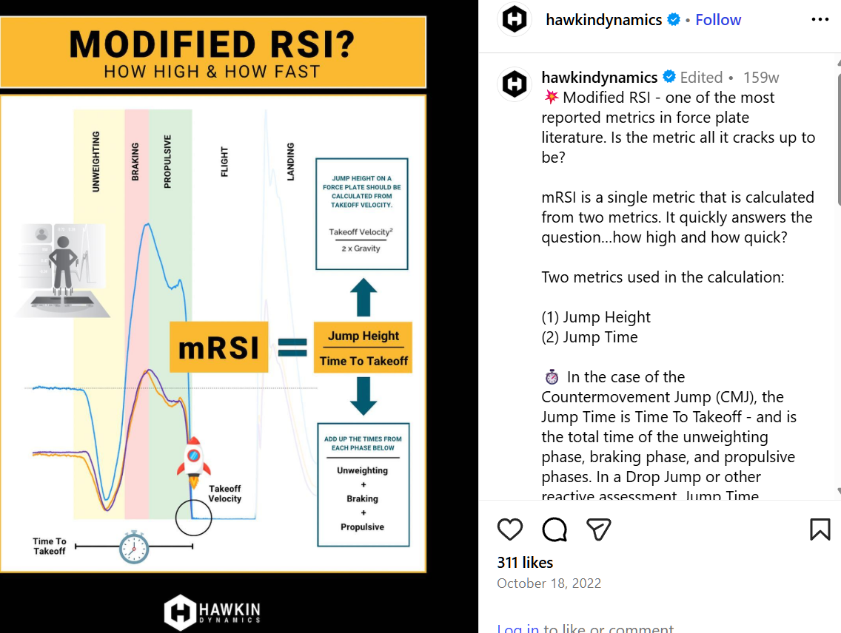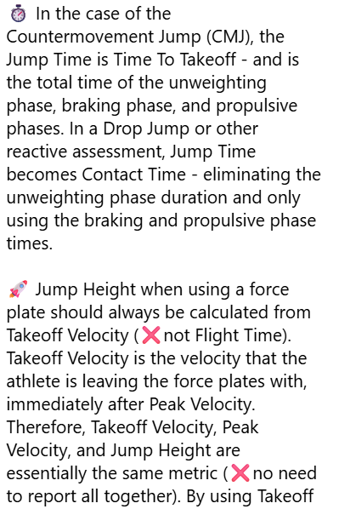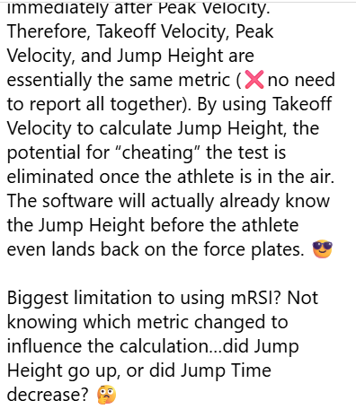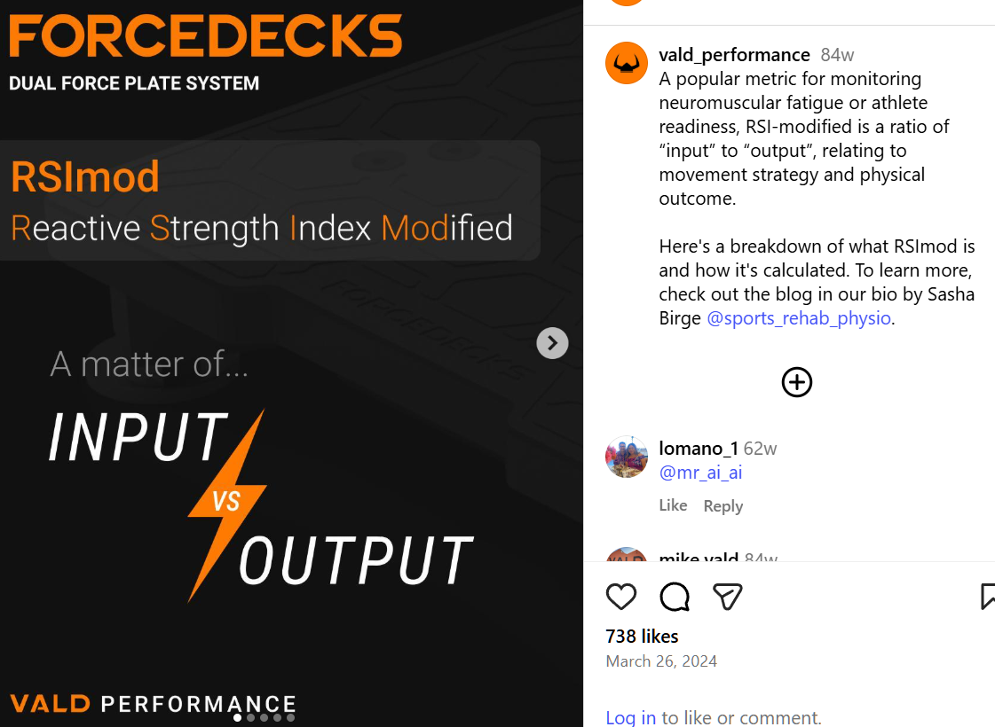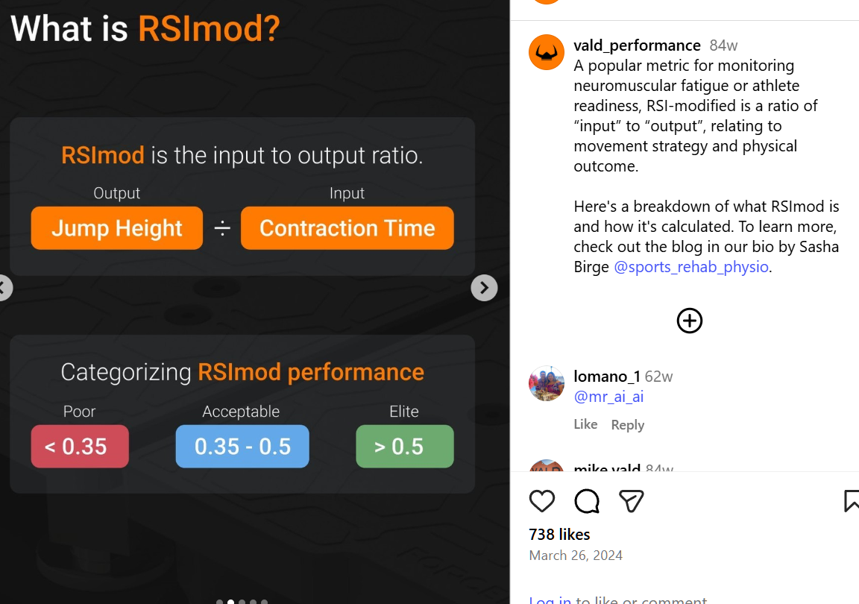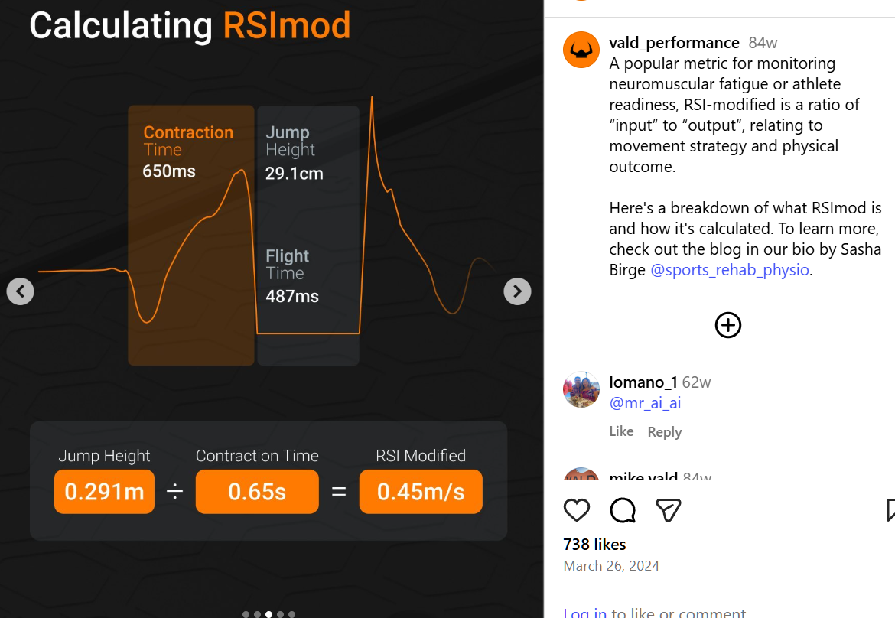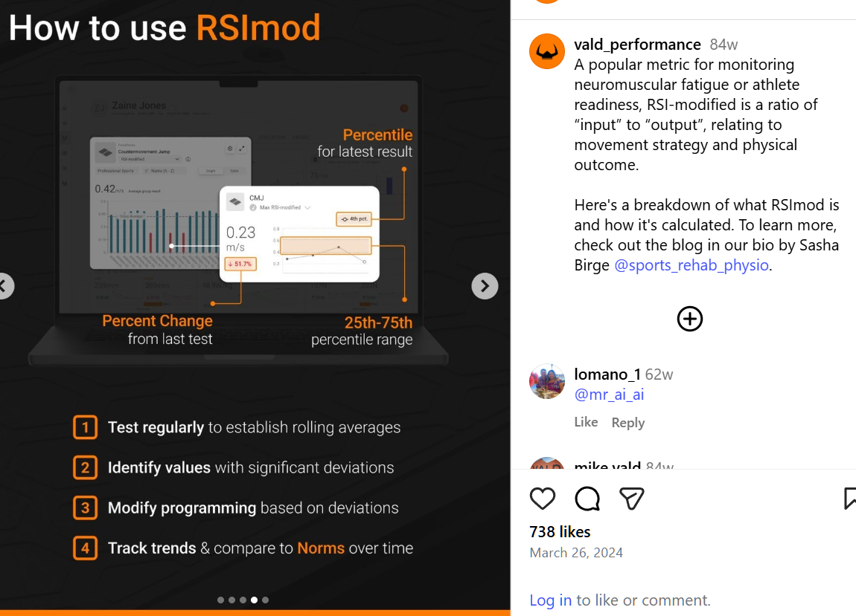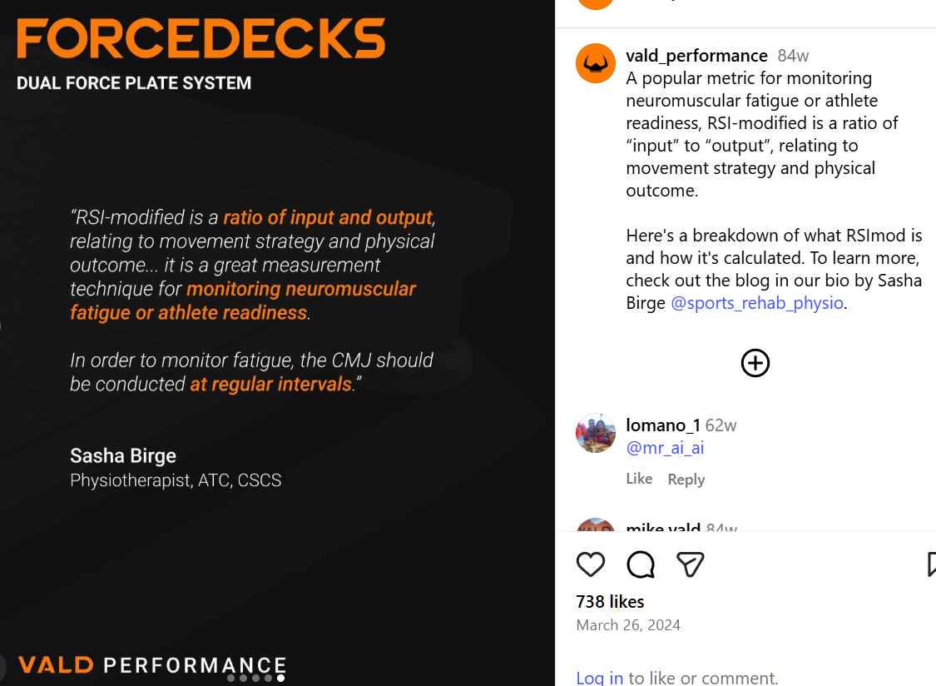

<https://www.semanticscholar.org/paper/A-Comparison-of-Reactive-Strength-Index-Modified-Suchomel-Sole/2d74d0fc38749c5097d0ea7d7820f2f4d7f7f1cb>

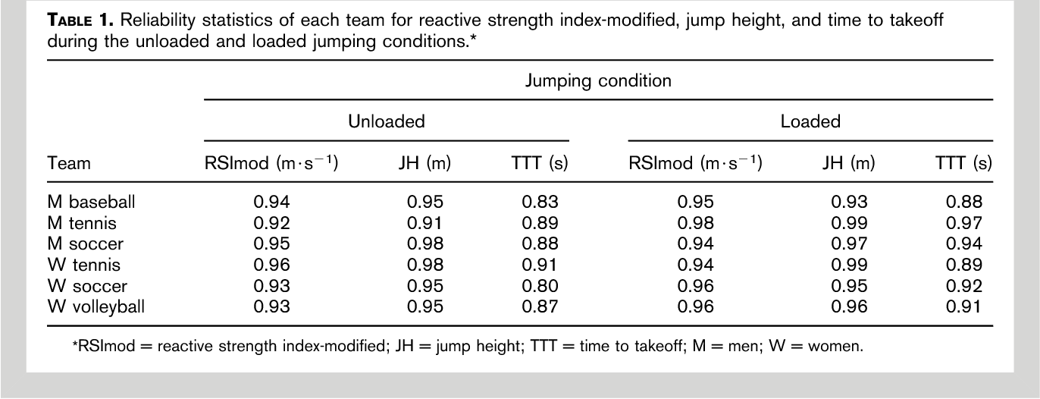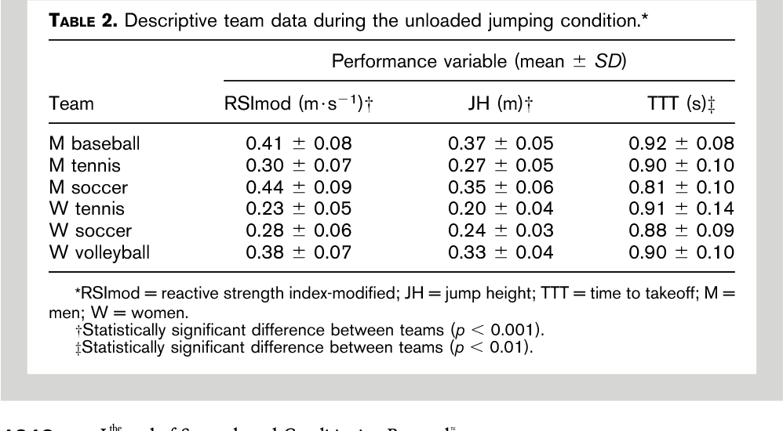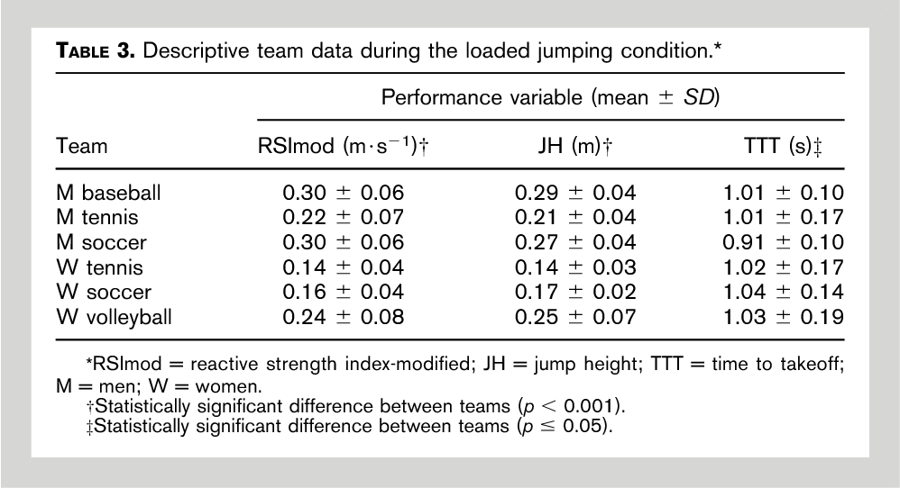https://coachmeplus.com/rsi-for-sport/

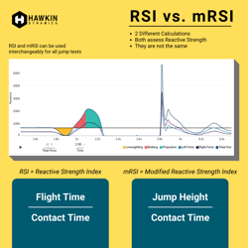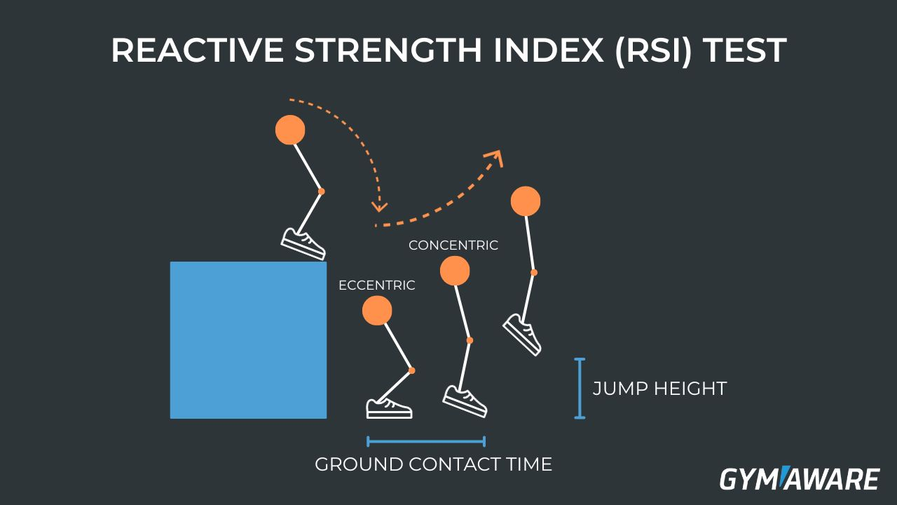 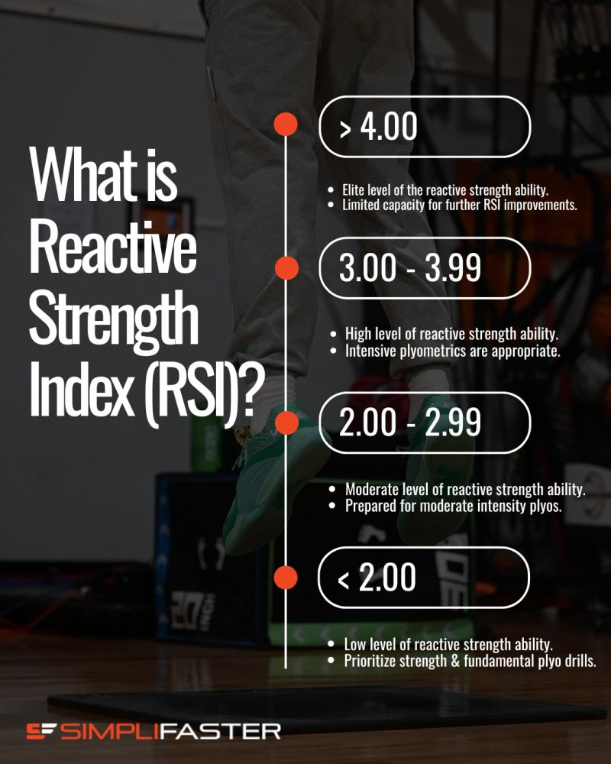 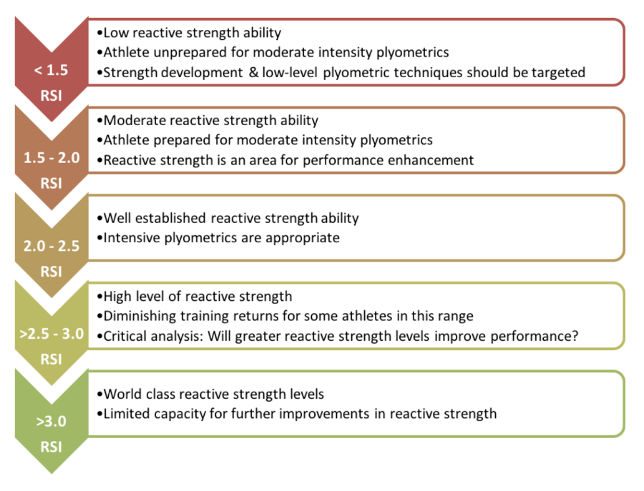

<https://www.sportsmith.co/wp-content/uploads/2024/11/Part-7-Plyometrics-Science-practice-of-reactive-strength-development.pdf>

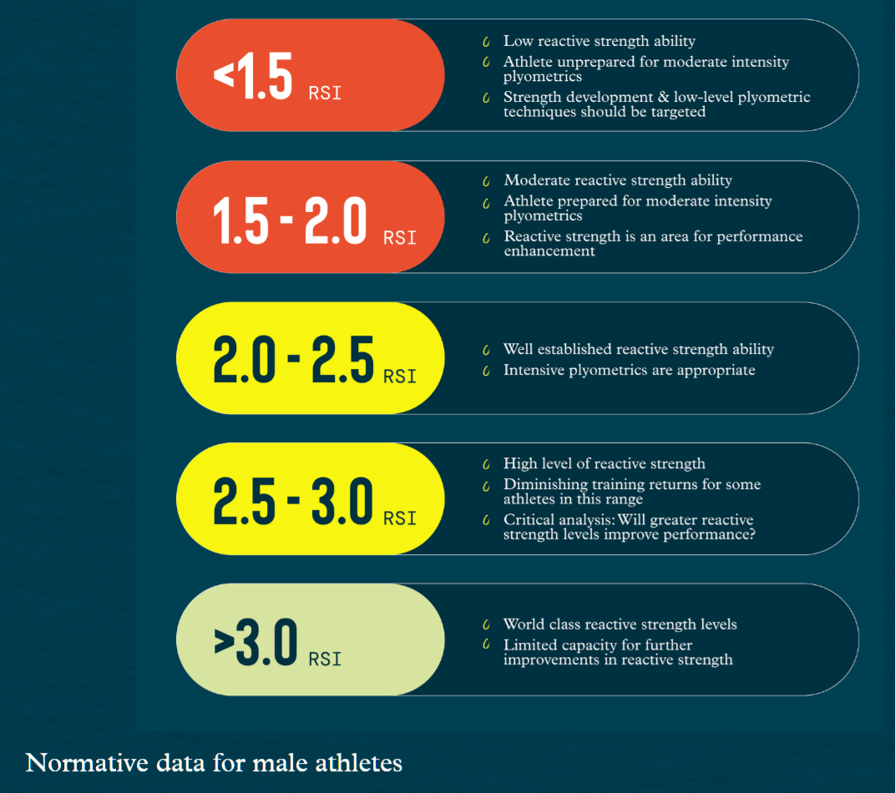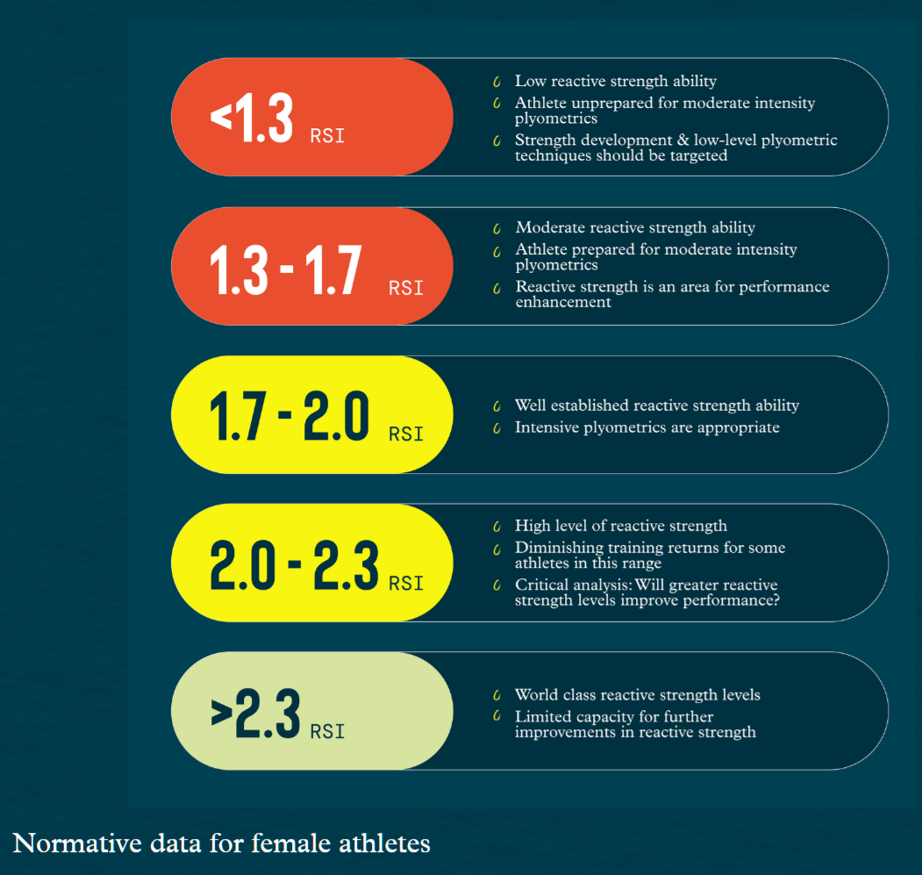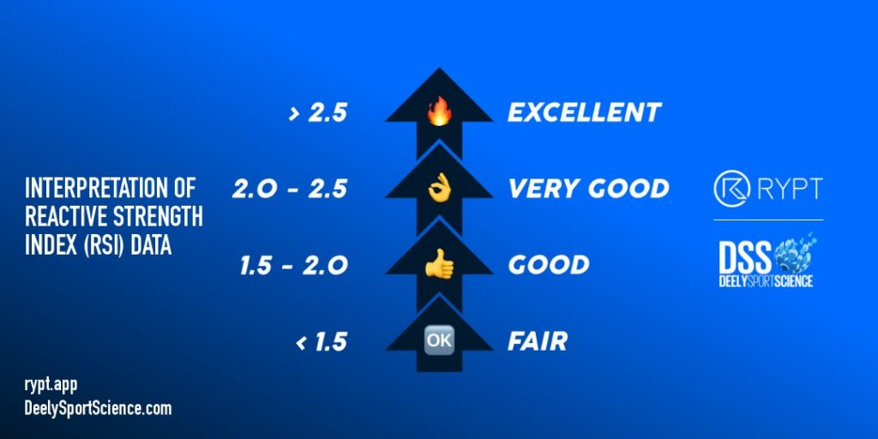

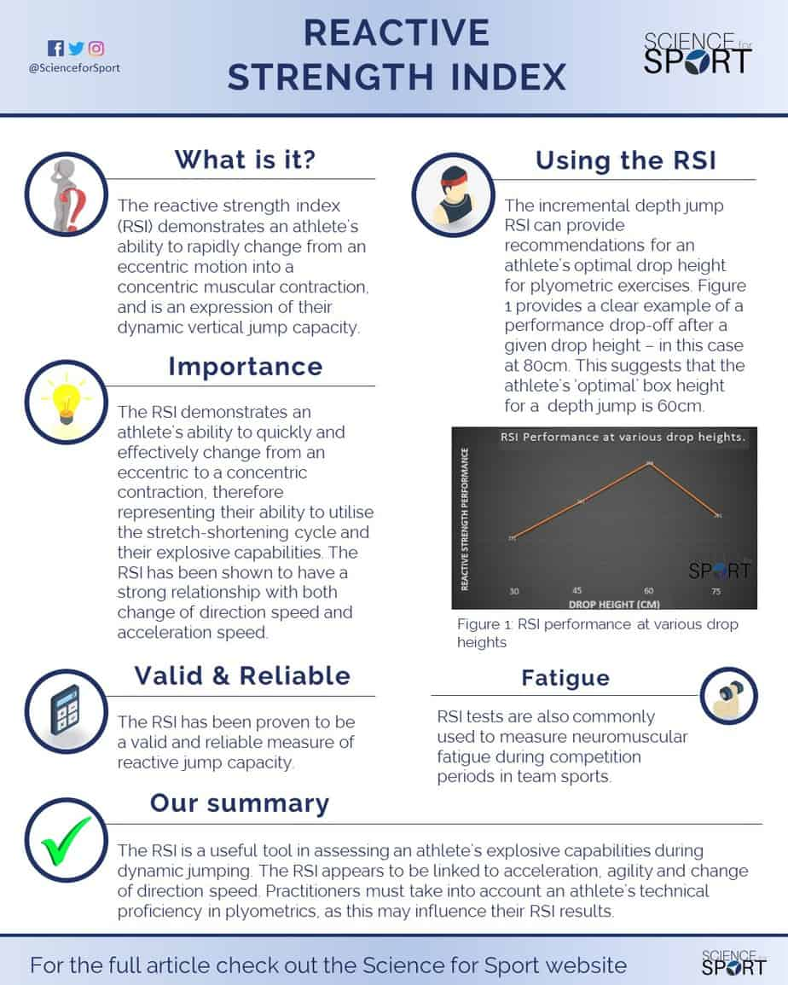

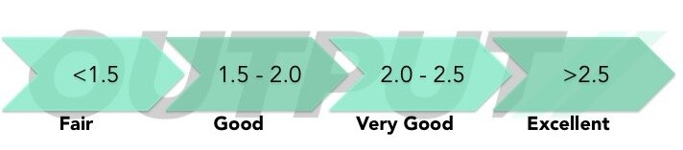

https://www.outputsports.com/blog/guide-to-reactive-strength-index

<https://pmc.ncbi.nlm.nih.gov/articles/PMC6315647/>

<https://pmc.ncbi.nlm.nih.gov/articles/PMC8309746/>

https://sportscienceinsider.com/reactive-strength-index-chart/

https://valdperformance.com/news/rsi-mod-made-simple